Project Documentation

1. **INTRODUCTION**

* **Project Title:** PNR RECIPIES
* **Team ID:** NM2025TMID38537
* **Team Leader:** Priyadharshini.R &[priyaramesh231106@gmail.com](mailto:priyaramesh231106@gmail.com) [Coder]
* **Team Members:**

* Nandhini.V [nanxx2143@gmail.com](mailto:nanxx2143@gmail.com) [Documenter]
* Navi.B [navi4092006@gmail.com](mailto:navi4092006@gmail.com) [ video Recorder]
* Rajakumari.B [rajakumarib971@gmail.com](mailto:rajakumarib971@gmail.com) [Coder]

**2.PROJECT OVERVIEW**

* **Purpose**: A cookbook's purpose is to be a culinary guide, offering recipes, cooking techniques, ingredient information, and cultural context to help people prepare and enjoy food. Beyond instruction, cookbooks serve to educate, preserve culinary traditions, share
* **Features:** Collection of Recipes – Contains a wide variety of dishes.
* Step-by-Step Instructions – Easy-to-follow cooking methods.
* Ingredients List – Exact quantities and alternatives.
* Preparation & Cooking Time – Helps in planning meals.
* Cooking Techniques – Explains methods like baking, frying, steaming, etc.
* Nutritional Information – Calories, proteins, fats, etc. (in modern cookbooks).
* Pictures/Illustrations – Visual guidance for presentation.
* Cuisine Variety – Recipes from different cultures and regions.
* Tips & Tricks – For better taste, storage, or substitutions.
* Index/Glossary – Quick access to recipes and terms.
* Target Audience Focus – Beginners, professionals, or healthy eaters.
* Meal Categories – Starters, main course, desserts, beverages, etc.

**3.ARCHITECTURE**

* **Frontend:** A frontend of "cookbook" involves structuring a project with HTML for content, styling it with CSS, and adding interactivity with JavaScript to build user interfaces.
* **Backend:** A "cookbook" for backend of includes essential concepts like servers, databases, and APIs, which work together to process data and respond to user requests.
* **Database:** A cookbook database's architecture involves a hierarchical structure, with the fundamental unit being the cookbook, which contains recipes and defines the desired state of a system. Other important components include [attributes](https://www.google.com/search?sca_esv=01d7d1da4f3739f4&cs=0&q=attributes&sa=X&ved=2ahUKEwis88rGq9CPAxWySmwGHR1EMP0QxccNegQIBRAB&mstk=AUtExfDfAi22YCzolMqsHmGQT7UPTgPlhcuaIsPpf9UCTUqw7PQgXQAksSz5miwHVkfOBy3Jx-o7cIUIKw7eB16vl_pLlxA2S_nQFRSz4DH4sMienGUGdgRGnud90tc0NOWi4TI&csui=3) (key-value pairs for settings), [libraries](https://www.google.com/search?sca_esv=01d7d1da4f3739f4&cs=0&q=libraries&sa=X&ved=2ahUKEwis88rGq9CPAxWySmwGHR1EMP0QxccNegQIBRAC&mstk=AUtExfDfAi22YCzolMqsHmGQT7UPTgPlhcuaIsPpf9UCTUqw7PQgXQAksSz5miwHVkfOBy3Jx-o7cIUIKw7eB16vl_pLlxA2S_nQFRSz4DH4sMienGUGdgRGnud90tc0NOWi4TI&csui=3) (for custom Ruby code and helper functions), and [metadata](https://www.google.com/search?sca_esv=01d7d1da4f3739f4&cs=0&q=metadata&sa=X&ved=2ahUKEwis88rGq9CPAxWySmwGHR1EMP0QxccNegQIBRAD&mstk=AUtExfDfAi22YCzolMqsHmGQT7UPTgPlhcuaIsPpf9UCTUqw7PQgXQAksSz5miwHVkfOBy3Jx-o7cIUIKw7eB16vl_pLlxA2S_nQFRSz4DH4sMienGUGdgRGnud90tc0NOWi4TI&csui=3) (describing the cookbook).

**4.SETUP INSTRUCTIONS**

* **Prerequisites:**

* + Node.js
  + MongoDB
  + Git
  + React.js
  + Express.js-MongOdb
* **Installation Steps:**

# Clone the repository git clone

# Install client dependencies cd

client npm install

# Install server dependencies cd ..

/server npm install

**5. PROJECT STRUCTURE**

**├──**Public

**│ ├──** src

**│ └──** components

├── images

│ └── pages

**├──** styles

├── App.css

└── App.js

**├──**App.test.js

│ ├── index.css

**│ └──**index.js

├── logo.svg

│ ├── gitignore

**│ └──**package-lock.json

├── package.json

│ └──README.md

**6. RUNNING THE APPLICATION**

* npm Start

• Access: Visit <http://localhost:3000>

**7. API DOCUMENTATION**

* **Landing Page Coding:**

import React from 'react';

import { useNavigate } from 'react-router-dom';

const LandingPage = () => {

const navigate =useNavigate();

* **signIn page Coding**

Vimport React from 'react';

import { useNavigate } from 'react-router-dom';

const SignIn = () => {

const navigate = useNavigate();

const handleSignIn = () => {

// Add your sign-in validation/login logic here if needed

navigate('/home'); // Redirect to home page after sign in

};

* **SignUp page coding:**

import React from 'react';

import { useNavigate } from 'react-router-dom';

const SignUp = () => {

const navigate = useNavigate();

const handleSignUp = () => {

// Add your sign-up validation/signup logic here if needed

navigate('/home'); // Redirect to home page after sign up

};

**8. User Interface:**

**Landing page:**

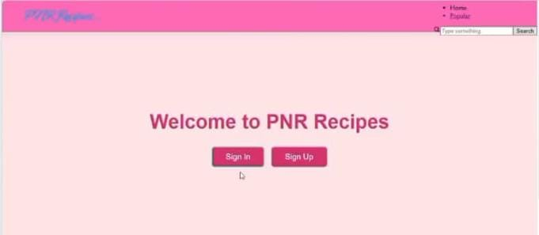

**SignIn page:**

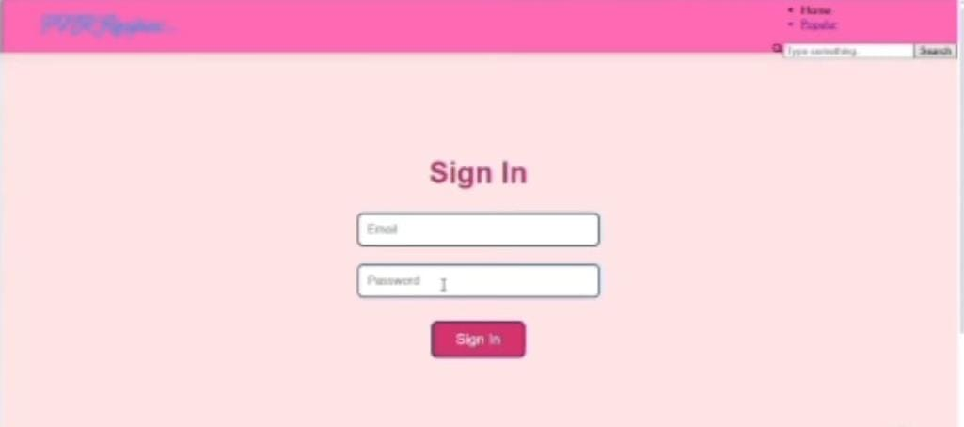

**SignUp page:**

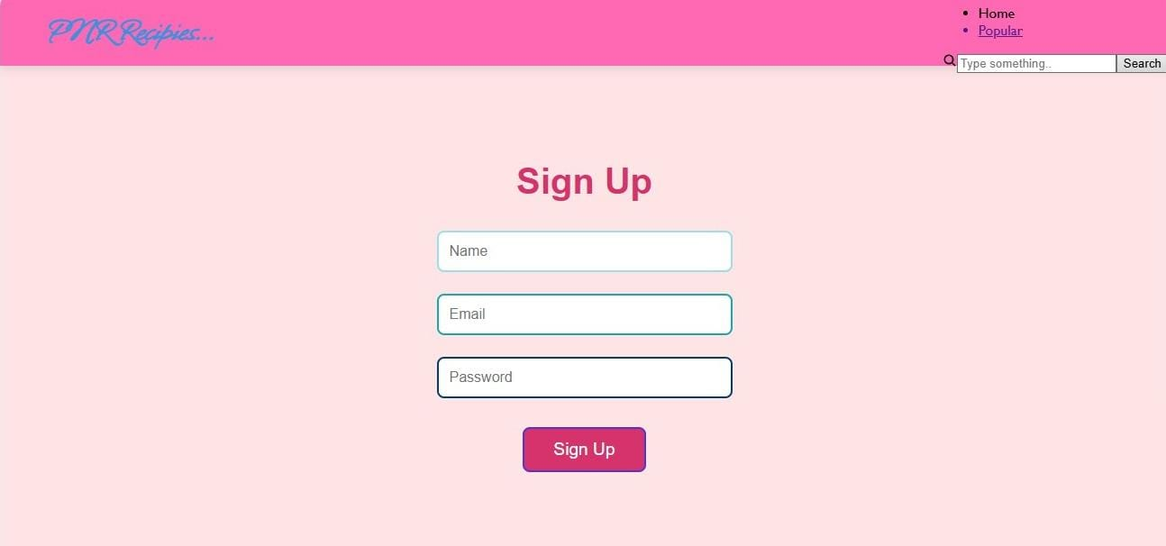

**Recipes page :**

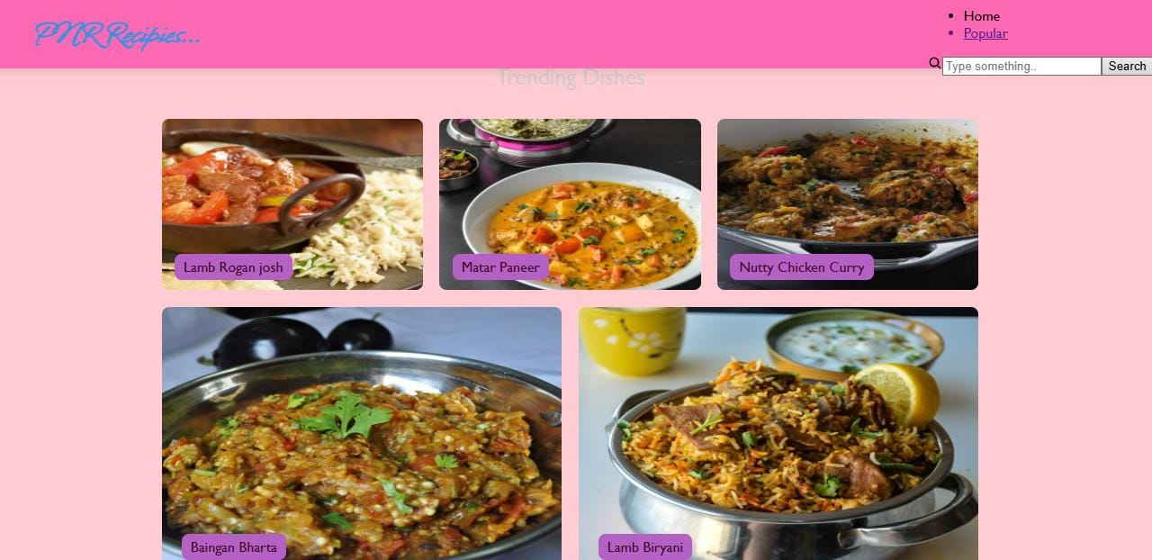

**9. DEMO Link:**

**https://drive.google.com/file/d/19Fs5O_l9qaye8PFYUHbK70g4WU49VY10/view?usp=drivesdk**

**11. FUTURE ENHANCEMENTS**

* **Multimedia Integration**: Embed short video tutorials for techniques, photo galleries of finished dishes, and even interactive elements like step-by-step visual guides.
* **Personalization**: Allow users to save their favorite recipes, create custom meal plans, and get personalized recipe recommendations based on their preferences and dietary needs.
* **User-Generated Content**: Implement a feature for users to leave reviews, rate recipes, share photos of their creations, and even submit their own recipes to be considered for the cookbook.
* **Interactive Tools**: Include a built-in shopping list generator from recipes, nutritional information calculators, and unit converters to make the cooking process more convenient.